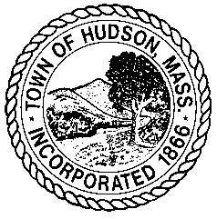
Town of Hudson - Board of Selectmen
Minutes – Wednesday, October 28, 2020
Remote via Zoom 5:00 PM

Call to Order:
Present were Mr. Durant, Mr. Duplisea, Mr. Lucy, Mr. Parent, Mr. Quinn and Mr. Moses. Also present was Ms. Vickery.

Personnel:
- Selectmen to consider approval of the appointment of Felipe Neto to the position of Community Contact Tracer for the Hudson Board of Health at $28.00 an hour, effective 10/29/2020.
On a motion by Mr. Lucy, seconded by Mr. Parent, the Board voted 5-0 to approve the appointment of Felipe Neto to the position of Community Contact Tracer for the Hudson Board of Health at $28.00 an hour, effective 10/29/2020.

Adjourn:
On a motion by Mr. Parent, seconded by Mr. Durant, the Board voted 5-0 to adjourn its meeting of October 28, 2020 at 5:05PM.

Document List – October 28, 2020

Document | Location
Felipe Neto Acceptance Letter, job application, resume | BOS Office
Contact Tracer Job Description | BOS Office
 | BOS Office
 | BOS Office
 | BOS Office
 | BOS Office
 | BOS Office
 | BOS Office
 | BOS Office

