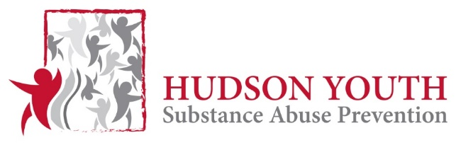
Hudson Youth Substance Abuse Prevention Coalition Agenda
January 15th, 2020 from 5:00-6:30 P.M.
Hudson Town Hall
3rd Floor Conference Room

Agenda Item | Time | Objective
Introduction | 5:00pm – 5:05pm | - Introducing any new members  - Updates from members
Announcements | 5:05pm – 5:15pm | - Updates on YSAP
Dodgeball Tournament | 5:15pm – 6:00pm | - Reviewing work remaining  - Donors and sponsorship reminder
Other Programming | 6:00pm – 6:25pm | - Shaws Bag deal  - Video Showing  - Upcoming Vaping Event at School  - Improbable Players
Next Steps | 6:25pm – 6:30pm | - Next Meeting Date

